Welcome to St. James Preschool

Parent Information

ST JAMES PRESCHOOL
St. James United Methodist Church
401 Carlwood Drive Miamisburg, Ohio 45342
Preschool telephone: 865-0272; Church 866-2431 Hours – 9:00am – 11:25am Mon/Wed/Fri. 12:20pm - 2:45pm Mon/Wed/Fri. 9:00 am – 12:00 pm Tues/Thurs

St. James Preschool Staff & Classes
Administrator – Mrs. Cindy Sorg

Beginner Classes
(Child must be 3 years old by Sept. 30th, 2019)

MWF - AM  T/TH - AM  T/TH - AM  MWF -PM | -Mrs. Fisher & Mrs. Hewitt  -Mrs. Espelage & Mrs. Copsey  - Mrs. Fisher & Mrs. Hewitt  - Mrs. Espelage & Mrs. Fisher

Pre-Kindergarten Classes
(Child must be 4 years old by Sept. 30th, 2019)

4-Day – AM  4-Day – AM  MWF – AM  MWF – AM  T/TH – AM  MWF – PM  MWF – PM  MWF – PM | - Mrs. Kusnerik & Mrs. Hill  - Mrs. Wasoski  - Ms. Foley & Mrs. Copsey  - Mrs. Tate & Mrs. Espelage  - Mrs. Tate & Mrs. Angerer  - Ms. Foley  - Mrs. Wasoski & Mrs. Angerer  - Mrs. Hill & Mrs. Kusnerik

CALENDAR 2019-2020

Our school calendar follows closely the Miamisburg Public School calendar. If weather conditions prohibit school in Miamisburg, we will also be closed. If the Miamisburg Public Schools are on a delay, we will be opening at our regular time. If these circumstances should arises, watch WHIO-TV for closing information on Public Schools or check our Facebook Page.

Our school’s policy on make-up days (due to the school being closed because of road conditions, energy, power failure, etc.) is that these days will be made up by adjusting the school calendar if they exceed the number of days a child is scheduled to attend in one normal week. (2 for the 2-day class, 3 for the 3-day class etc.) These days are to be scheduled within the Miamisburg Public Schools calendar.

August 26 & 27 Open School (by appointment only)
August 28 & August 29 First Day of School
September 2 Labor Day
October 14 – October 18 Fall Break
November 27 - November 29 Thanksgiving Vacation
December 23 – January 3 Christmas Vacation
January 20 No School (Martin Luther King Day)
February 14 No School (Public Schools Closed)
February17 No School (President’s Day)
February 27 – February 28 No School (Parent-Teacher Conferences)
WELCOME TO ST. JAMES PRESCHOOL
Our weekday Preschool, sponsored by St. James United Methodist Church is a community ministry of the Church. Here we seek to provide experiences that will help your child to grow in many ways -- physically, emotionally, spiritually, socially, and intellectually. We also seek to provide a Christian (non-denominational) atmosphere in which love, understanding, and individual concern make this growth possible. We will help your child grow in independence and in his adjustment to the world beyond the home.
We do not discriminate in the enrollment of children upon the basis of race, color, religion, sex or national origin, or disability. This is in violation of the American with Disabilities Act of 1990 Stat.
32, 42 U.S.C. 12101et seq.
To accomplish our goals we feel it is important to have small classes; therefore, our maximum class size is set at 17 children with 2 teachers. The number of children that St. James Preschool is licensed to serve is found on our license displayed in the Preschool office area.
Our school is well equipped to enable the teachers to carry out their planned activities. Each activity is based on our goal to create an environment where self-discovery can naturally occur and through group experiences new concepts can be explored together.
A typical session at our school would include a variety of activities to aid in the development of the whole child. Large muscle development is focused on during the time set aside for active play. Small muscle activities, such as cutting with scissors, pasting, finger painting, manipulation play dough and others are emphasized to strengthen little hands and improve eye-hand coordination. Self-concepts will be strengthened through activities involving dramatic play, increased problem-solving ability, and positive reinforcement. Opportunities to develop social skills will occur during snack time, dramatic play, or group games. Planned activities for cognitive development will take place in the areas of math, science, music, language, arts, etc., throughout the session. The teachers, trained in early childhood education techniques, will catch that special moment to explain a math concept, develop a language skill, or point out a wonder of nature, as the opportunity presents itself during the time your child is with us A visit to our school is an excellent way to gain a better understanding of our philosophy. This will let you see our program and ask questions not answered in this brochure. After enrolling your child, we

April 3 No School (Teacher Inservice Day) encourage you to visit throughout the year. We suggest a minimum of two visits to give you a chance to
April 6 – April 10 No School (Spring Break) see changes in your child. Although you are welcome at any time, please try to schedule your visits with
your child’s teacher ahead of time as we do like to limit the number of visitors per session. Upon
May 21 Preschool Farewell- 9:00 – 10:25 Tues/Thurs Classes/ entering the premises, the custodial parent, custodian or guardian shall notify the Director or the Four day classes child’s teacher of his presence.
May 22 Preschool Farewell- 9:00 - 10:25 MWF AM classes We are here to help you and your child have a positive experience in school. If you have any concerns Preschool Farewell- 12:20- 1:45 All PM classes or questions about our program, please let us discuss them with you.

PHILOSOPHY

It is God’s intention that we develop our potential as human beings created in His image. This potential will be enhanced by fostering physical, emotional, intellectual, social and spiritual growth in ourselves and our children. Each person is unique and this uniqueness is considered the basis for development of each area.

GOALS

- Each child will be encouraged to pursue his/her development. The staff recognizes the importance of balanced growth so they provide opportunities for mental, physical and emotional growth through a variety of creative experiences.
- Each child will be encouraged to pursue this development as far as he/she is able given the resources we have available.
- No child will be expected to enter any activity he/she has not shown a readiness to engage in.
- Each child will be encouraged to feel about himself in a positive way.

LICENSE

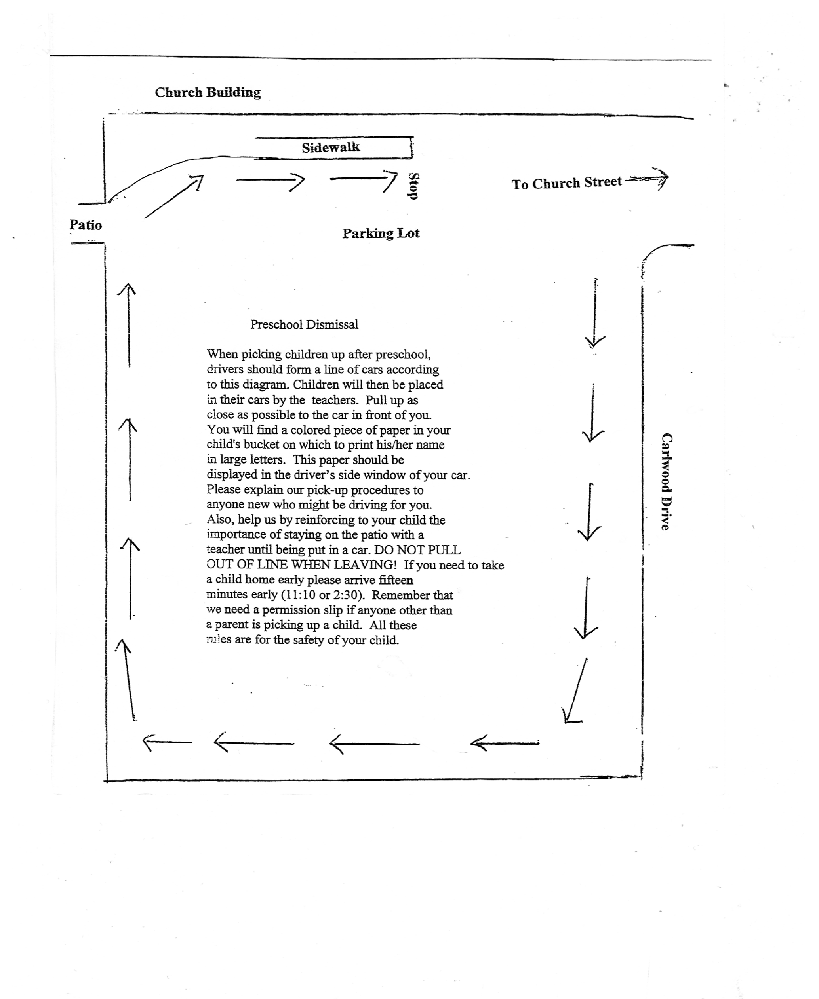
At the end of the handbook you will find an attachment about licensing and other valuable information. Please take the time to read this information.

ADMISSION TO OUR PRESCHOOL

A child is considered to be enrolled in the preschool only after the registration fee has been received, the administrator confirms the availability of space and the required paperwork is received and reviewed and approved by the administrator. This includes basic enrollment and health information. Any change to this information must be communicated to the office immediately so that current information is always on file. This is for the safety of your child. A medical form signed by a physician or certified nurse practitioner is required to be submitted within 30 days of admission. This medical must be updated every 13 months.

STAFF/CHILD RATIOS AND MAXIMUM GROUP SIZE

Our policy at St. James Preschool is to limit enrollment to 17 or 18 children per class, with two teachers responsible at all times. The State of Ohio will license centers for this age child for one teacher for every 14 four & five-year old’s and one teacher for every 12 three-year old’s. We will continue our present policy of one teacher for every nine or ten children. Also, please refer to our staff/child ratio signs posted at the entrance of each classroom area.

GUIDANCE POLICY

St. James Preschool staff believes that helping the child to learn self-control is very important. Our hope is that each child will learn self-discipline through careful guidance. Your child will be treated with love and respect. If children are treated with respect, they in turn learn to respect the teachers and their friends. Our expectations will be kept within the child’s capabilities and the child will be made aware of positive redirection (removing the child and giving them an appropriate activity) will be used. A child may be asked to sit for a short period of time to give the child a chance to regain control if they are having a difficult time. We rarely feel the need to use time out because generally speaking, these disturbances are at a minimum in our preschool. However, if a time out is needed it will be age appropriate in length and done within the classroom. Teachers will not impose punishments for failure to eat or toileting accidents. This discipline policy applies to all teachers, administrator and parents while they are at the Preschool.

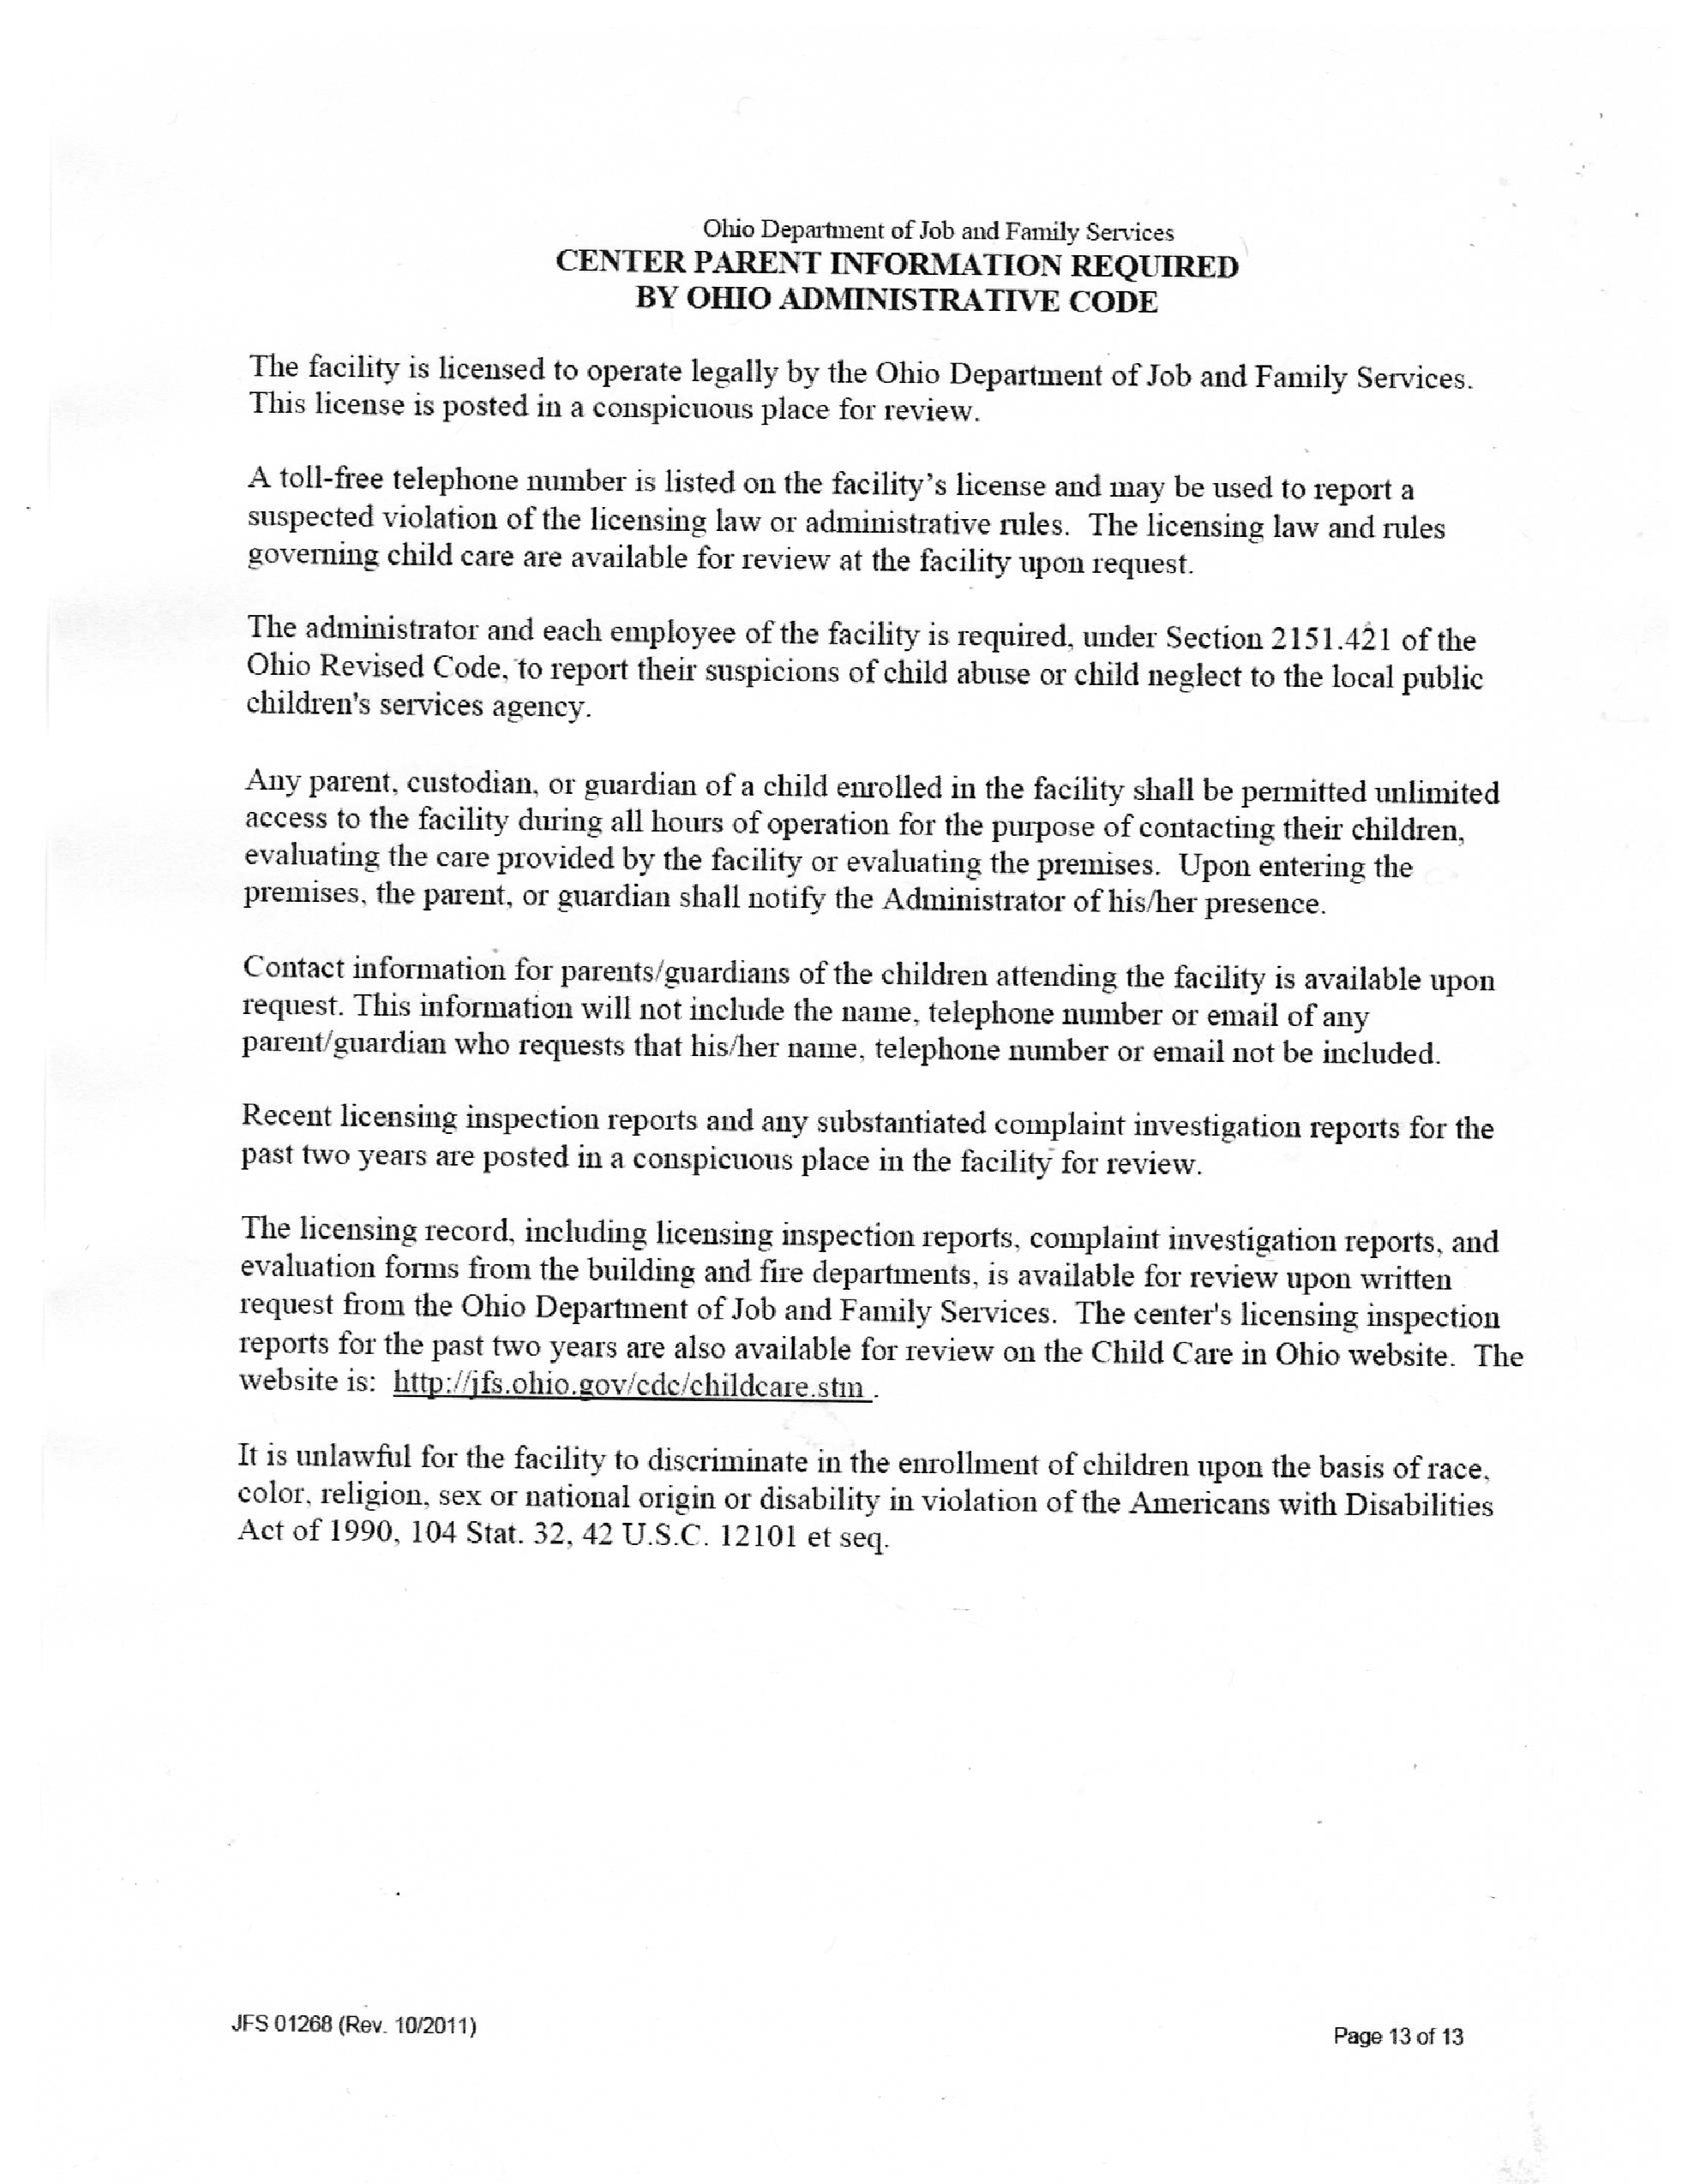
If a situation arises where a child is consistently endangering himself, peers or teachers, it may become necessary to disenroll the child. Every attempt will be made to work together with the parents and the child to correct the behavior. However, the safety of the children is always are primary concern. The administrator would be in communication with the parents prior to this occurring. If the child demonstrates behavior that requires frequent “extra attention” from the teachers, we may choose to develop and implement a behavior management plan. This plan would be developed in consultation with the parents and would be consistent with the requirements of Rule 5101: 2-12-22 OAC.

OUTDOOR PLAY

Research has shown that children stay healthier when they have daily outdoor play. Based on this information and state requirements, outdoor play will be included in our program on a daily basis. We will limit the amount of time outside when the temperatures are very warm or very cold. Children will not be taken outside when the temperature (wind chill and heat index factored in) drop below 20 degrees or rise above 90 degrees. If the situation requires it we will also adjust outdoor time due to rain, threatening weather, ozone warnings, etc. On days that outdoor play is not provided due to these conditions, we will include a time for indoor gross motor activities. Please send your children with the proper clothing so they may be comfortable and safe whenever we are outside.

FIELD TRIPS

Written parent/guardian permission is required for all trips. The only field trips we take at St. James Preschool are all within walking distance of the facility. Each teacher will have a list of the children with them so that children can be accounted for at all times; both at the school and at the destination.

PARENT PARTICIPATION – POLICY

A visit to our school is an excellent way to gain a better understanding of our philosophy. This will let you see our program and ask questions not answered in this handbook. After enrolling your child, we encourage you to visit throughout the year. Parents may wish to attend fieldtrips, class parties or simply stop in to join the daily fun. Informal activities that encourage parental participation at the preschool may include: reading stories, art projects, playing games, serving as a resource person, or helping with special parties. We suggest a minimum of two visits during the year will give you a chance to see changes in your child. Please schedule your visit with your child's teacher ahead of time as we try to limit visitors to two adults per session.
Any custodial parent, custodian, or guardian of a child enrolled in preschool shall be permitted unlimited access to the preschool during its hour of operation for the purposes of contacting their children, evaluating the care provided by the preschool or evaluating the premises. Upon entering the premises, the custodial parent, custodian, or guardian shall notify the administrator or the child's teacher of his/her presence.
It is our policy to provide a class roster to all preschool families. Upon registration families have the choice of whether or not they would like their name and/or telephone number to be included on the roster.
Teachers are available to discuss a child’s progress or needs at any time. However, due to teacher responsibilities and schedules, parents are asked to make appointments with their teachers when it is necessary to engage in any lengthy conversations. Teachers want to be able to focus on you and your child at these times. Please note that parent-teacher conferences are scheduled on a yearly basis. We are here to help you and your child have a positive experience in school. If you have any concerns or questions about our program, we invite you to discuss them with your child's teacher or the administrator. You may make an appointment with us or stop by informally if you prefer. Our staff fully realizes that you are trusting us with your little ones and we want our relationship to be a good one.

A TYPICAL DAY AT THE PRESCHOOL

ARRIVAL - Children are greeted by teachers, put coats and buckets away, and find their names on the names board.

CLASSROOM TIME (75 minutes total time)
- Daily projects (art, science activities, math activities, fine motor skills, etc. 25-30min
- Learning Centers (block center, books and puzzles center, dramatic play center, housekeeping center, manipulatives center) 25 - 30 minutes
- Clean up time (children assist teachers in picking up toys, cleaning project tables, removing name tags) 10 minutes
- Group time (classroom discussion, children’s literature, sharing, special day time) 15 minutes

LARGE MOTOR ROOM (30-35 minutes total time)
- Snack time- 10-15 minutes (We will serve a snack each session)
- Group time (Circle time, music activities) 10 - 20 minutes
- Water play, easel painting, climbing, large block building 15 minutes

MUSIC/ STORYTIME (30 - 35 minutes total time)
- Songs, stories, discussion, special day, sharing time

DISMISSAL (10 minutes)
- Putting on coats and hats, getting buckets, walking out of the building - 10 minutes

SUPERVISION POLICY

Adults responsible for children in this school will consider the health and safety of each child to be our first concern. Staff persons are alert to the safety needs of their children, anticipate possible hazards and take necessary appropriate precautionary and preventative measures. All other goals of this school such as the physical, emotional, spiritual, and cognitive development shall be considered only after the safety of each child is assured.
All parents/guardians must realize that even within a well- structured highly supervised and well-equipped program, children can have accidents. Those parents/guardians who are not willing to expose their children to the normal risks involved when children begin to enter the world outside and begin to leave the protected environment of the home should not enroll their children in any preschool program. Our safety policies go far beyond the State minimum requirements and would take many pages to detail here. We are listing here the requirements of the State. Each classroom and situation in our school has additional safety regulations.
There will be the following regulations in our school:

- SUPERVISION: All children will be supervised at all times. No child shall ever be left alone or unsupervised. If a child becomes ill, they may be isolated in a section of the room not in use, but within the sight and hearing of a staff member.
- ARRIVAL/DEPARTURE: The adult bringing the child to the center will escort each child to his/her classroom and will not leave until the teacher has shown recognition of the child's presence. Any special messages, medications, special pickup notes etc. are to be given to the teacher. Children may not be dropped off at the entrance of the building or be sent inside alone. Teachers must be made aware of each child’s presence before the adult departs. When departing from preschool, children will be placed in their car by a teacher. Please have the name of your child displayed in the car window. If parent’s/adults are coming in to pick up the child, they are asked to make contact with their child’s teacher and the teacher will acknowledge
- SCHOOL CANCELLATIONS: On occasions, it may be necessary to close the Preschool due to poor weather conditions. We currently follow the Miamisburg City Schools
- RELEASE OF A CHILD: By the first day of school for any child, the parent or guardian will provide St. James Preschool, in writing, the names of all persons able to pick up their child from Preschool. If there is a change, either temporary (one day) or permanent, the child will bring in writing, the name of the person/persons the child is to leave with. In case an emergency arises during the time the child is at the preschool, the parent of guardian may call and give the above information, by phone, to a responsible adult. Staff will check ID’s of anyone they do not recognize. Please let people know about this ahead of time so they bring a picture ID and they are not offended. The children’s safety is our priority! Staff will not release children to anyone, including parents, who appear to be under the influence of drugs of alcohol. Emergency contacts will be called to transport the child home. Police will be notified if necessary.
- CUSTODY AGGREMENTS: If there are custody issues involved with your child, you must provide the Preschool with court papers indicating who has permission to pick up the child. The Preschool many not deny a parent access to their child without proper documentation.
- CHILD ABUSE REPORTING: All staff members are mandated reporters of child abuse. If staff has suspicions that a child is being abused or neglected, they MUST make a report to the local children’s services agency. The safety of the children is our first concern.

MANAGEMENT OF ILLNESSES

The staff at St. James Preschool is trained in First Aid, CPR, Communicable Disease, and Child Abuse recognition as per ODJFS requirements. St. James Preschool provides children with a clean and healthy environment. However, we realize that children become ill from time to time. If this is your child’s first group care experience, it is possible that they may experience more frequent illnesses at the beginning before their immune system becomes more active. We observe all children as they enter the program to quickly assess their general health. We ask that you not bring a sick child to preschool. They will be sent home! Please also plan ahead and have a backup care plan in place if you are not able to take time off from work/school.

A child with any of the following symptoms will be immediately isolated and discharged to the parent or emergency contact:
- Temperature of 100 degrees F – in combination with any other signs of illness
- Diarrhea
- Severe coughing (causing the child to become red in the face or to make a whooping sound)
- Difficult or rapid breathing
- Yellowish skin or eyes
- Redness of the eye or eyelid, thick and purulent (pus) discharge, matted eyelashes, burning, itching or eye pain.
- Untreated skin patches, unusual spots or rashes
- Stiff neck with elevated temperature
- Evidence of untreated lice, scabies or other parasitic infestation • Vomiting more than once or when accompanied by any other sign of illness
- Sore throat or difficulty swallowing.

Any child demonstrating signs of illness not listed will be isolated and carefully observed for symptoms. The parent will be notified. If a child does not feel well enough to participate in preschool activities the parent will be called to pick-up the child. Anytime a child is isolated they will be kept within sight and hearing of their teacher or in the administrators office. The sick child shall be provided with a cot and blanket for use until he/she is discharged to their parent. The cot shall be sanitized with an appropriate germicidal detergent upon the discharge of the child. The blanket shall be promptly removed and laundered before being used by another child.

To protect and alert other families in our school, please notify the school early of any communicable disease and the date it was first recognized. We can then send notes to those families whose child may have been exposed. Children will be readmitted to the Preschool after at least 24 hours of being free of fever and other symptoms. If they are not symptom free a doctor’s note will be required stating that the child is not contagious.

(NON) ADMINISTRATION OF MEDICATION – POLICY

The personnel of St. James Preschool will not administer medication to any child. If a child is considered well enough by a physician to be in school and there is a need to administer medication to this child, a parent or another adult with written authorization from the parent must visit the school and administer the medication. Children who have severe allergies that require the emergency administration of medication, food supplements, or modified diet will see the teacher to fill out the appropriate paperwork and conduct the appropriate training. All medications will be kept out of the reach of children.
St. James Preschool will not allow children to have and use inhalers.

POLICY ON EMERGENCIES AND ACCIDENTS:

St. James Preschool has devised several procedures to follow in the event that an emergency would occur while a child is at the preschool. They are as follows:
- In the case of a minor accident/injury to a child, the staff will administer basic first aid and
TLC. (please note there is always one staff member present that has received training in First Aid/Communicable Diseases and CPR) If the injury/illness would be more serious, first aid would be administered and the parents would be contacted immediately to assist in deciding an appropriate course of action. If an injury/illness is life threatening, the Miamisburg Paramedics will be contacted at 937-866-3344, parents will be notified, and a staff member will accompany the child to the hospital with all available health records. Staff will not transport children in their vehicles. Only parents or EMS will transport. If a child is injured while at school, the child’s teacher will complete an Incident/Injury report and provide parents with a copy of the report.
- In the event of a fire or tornado, teachers would follow the written instructions posted in each classroom, describing emergency evacuation routes and the procedures to be followed to assure that children have arrived at the designated spot. In order to prepare children for the unlikely need to evacuate, the center does conduct monthly fire drills, and periodic tornado drills. Lockdown procedures are also practiced on a quarterly basis.
- In the event we need to evacuate the premises due to fire or weather conditions, or the loss of power, heat or water to the Preschool, our emergency destination is the Miamisburg Post Office which is located at 240 S. Heincke Rd. A sign will be posted in front of the Preschool indicating that we have been evacuated and the location where you can pick up your child. Parents will also be contacted as soon as possible to come to pick up your child. If a parent cannot be reached, we will contact the emergency contacts as listed on your child’s enrollment information.
- In the unlikely event there would be an environmental threat or threat of violence, the staff will: secure the children in the safest location possible, contact and follow the directions given by the proper authorities and contact the parents as soon as the situation allows. An incident report would also be provided to the parents.

TUITION FEES AND PAYMENT POLICIES

Tuition is due the first class session of each month. Please send tuition in the envelope provided in your child’s bucket. We will send the payment envelopes home at the end of each month. A late fee of $10.00 will be charged after the fifteenth of the month.

The total tuition is figured for the school year based on the total number of days the class is in session.
This amount is divided into nine equal payments. The last payment is due the first class session in May. We appreciate quarterly payments if possible. Monthly tuition payments are as follows:
Two day a week classes…………………………. …$ 95.00 ($285 quarterly)
Three day a week classes……………………………$125.00 ($375 quarterly)
Four day a week classes………………..……………$160.00 ($480 quarterly)

As stated on your registration form, when a child is accepted it is for the entire year. If circumstances arise that a child would have to withdraw due to relocation or illness, we require two weeks’ notice so that we can fill the vacancy.

Please be prompt when picking up your child after class. There is a $5.00 late fee for every ten minutes, after the official dismissal time, that a parent is late.

We will follow the policy of the Miamisburg Public School system for bad weather school closings.
Please listen to your radio. If weather conditions prohibit school in Miamisburg, we will also be closed.

IF THE MIAMISBURG PUBLIC SCHOOLS ARE ON A DELAY, WE WILL BE OPENING AT
OUR REGULAR TIME. Listen to the radio for Miamisburg Public Schools closing announcements.

