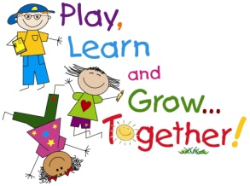
ST. JAMES PRESCHOOL
401 Carlwood Dr.
Miamisburg, OH 45342
937-865-0272
August 1, 2020

Dear Parents:
The novel coronavirus, COVID-19, has been declared a worldwide pandemic by the World Health Organization. As a result, federal, state, and local governments and agencies recommend social distancing and have, in many locations, prohibited the congregation of groups of people.
We are doing everything we can to be compliant with all regulations and ensure your safety. We have put in place preventative measures to reduce the spread of COVID-19, but we cannot guarantee that you or family members will not become infected with COVID-19.

By participating in programs, services, and activities of St James Preschool, you agree to the following:

On behalf of yourself and your children, you hereby release, covenant not to sue, discharge, and hold harmless St. James Preschool , its employees, agents, and representatives, of and from all liabilities, claims, actions, damages, costs or expenses of any kind arising out of or relating to your participation in our programs, services or activities. You understand and agree that this release includes any claims based on the actions, omissions, or negligence of this organization, its employees, agents, and representatives, whether a COVID-19 infection occurs before, during, or after participation in any such program, service or activity.

Parent Signature: ___________________________________
Printed Name: _______________________________________
Date: ____________________
Names of Children enrolled:
__________________________________ __________________________________
__________________________________ __________________________________

