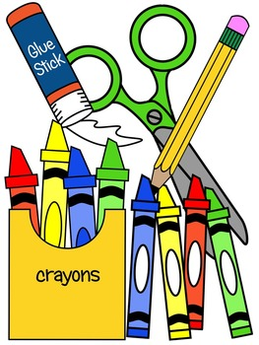
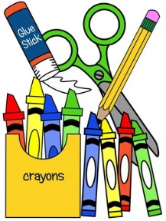
2020-2021 Preschool Supply List

(Due to Covid 19 Virus we are asking for Parents to supply the following School Supplies)

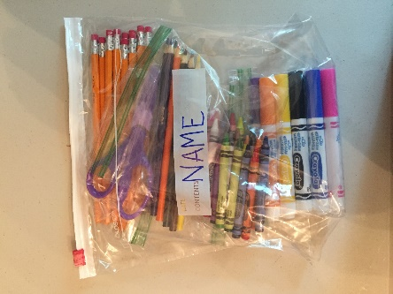
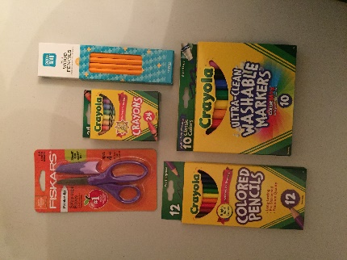
24 pack of Crayons
Washable Classic Markers
Scissors
Colored Pencils
Regular #2 pencil

**Please put above items in individual zip lock bags and then combine all into one gallon size bag with child’s name on the outside!**

In addition to above items we are also in need of any of the following items:

5oz paper cups
Paper Towels
Klennex Tissues
Lysol Spray
Clorox Disenfecting Wipes
Hand Sanitizer
Hand Sanitizer Wipes (Handi Wipes)
Pre-Packaged Snacks

As always Thank you for your continued support of our preschool program. We are so appreciative of our wonderful parents!!!

